

Renewable Energy Potential of Argentina

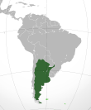

November 2009

Peter Meisen
President, Global Energy Network Institute (GENI)
www.geni.org
peter@geni.org (619) 595-0139

Catalina Ruiz Gutierrez
Research Assistant, Global Energy Network Institute (GENI)
catalina.ruizgutierrez@gmail.com

Table of Contents

Current Situation Page 3
Politics Page 5
Current Sources of Energy Page 8
Renewable Energy Potentials of Argentina Page 14
Legislation Page 18
Ongoing Projects Page 20
Argentina and its Neighbors Page 22
Conclusions Page 25
Biography Page 26

Table of Figures

Figure 1: Aconcagua Page 3
Figure 2: Pumamarca Page 3
Figure 3: Tilcara Page 3
Figure 4: Iguazu Falls Page 4
Figure 5: Pampa Humeda Page 4
Figure 6: Bariloche, Patagonia Page 5
Figure 7: Caserolazo at the Pink House Page 6
Figure 8: Manifestation at Florida St Page 6
Figure 9: Farmers Act 2008 Page 7
Figure 10: Farmers Act 2008 Page 7
Figure 11: El Chocon, Hydroelectric Station Page 8
Figure 12: Argentine Demand. Market Statistics Page 11
Figure 13: Primary Energy Production Page 12
Figure 14: Map of Potentials per Region Page 14
Figure 15: Map of Hydro Potential Page 15
Figure 16: Map of Bio-Energy Potential Page 16
Figure 17: Map of Wind-power Potential Page 17
Figure 18: Power to Tender in the GENREN Program Page 18
Figure 19: Ongoing Renewable Energy Projects Page 20
Figure 20: South American Interconnection Agreements Page 23
Figure 21: Energy transportation in South America Page 24

Current Situation

Argentina is located in South America. It has an area of almost 3.8 million square kilometers (more than one third of the US), 2.8 on the continent. Approximately 54% are plains (grasslands and savannahs), 23%, plateaus, and the other 23%, mountains. This variety gives Argentina a great potential for almost all renewables sources of energy. It shares borders with Uruguay, Brazil, Paraguay, Bolivia and Chile with a perimeter of 9,376 Km, while the territory bordered by the Atlantic Ocean is 4,725 Km long.
Argentina’s main characteristic is the enormous contrast between the immense eastern plains, ideal for solar or wind power, and the impressive Andes mountain range to the west, ideal for hydro and wind to some extent. The Andes are the frontier with Chile and boast the highest peak in the Western hemisphere: the 6,959 m high Aconcagua.

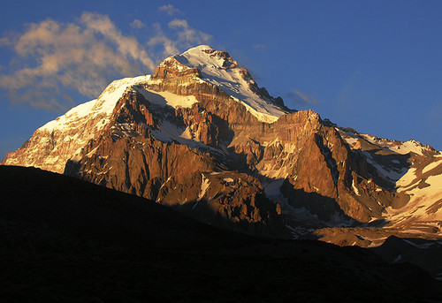
Figure 1 Aconcagua

From Jujuy to Tierra del Fuego, the Andes present marvelous contrasts: the Northwest plateaus with solar potential, the lake region with all its snowmelt rivers perfect for hydro, the forests and glaciers in the Patagonia.

To the northwest: Salta, Jujuy, Tucuman, the landscape changes completely. Its long and sunny days make it an ideal spot for solar and bio-mass.

Figure 2 Pumamarca (7 Colours Hill) Figure 3 Tilcara. At the very north of the country

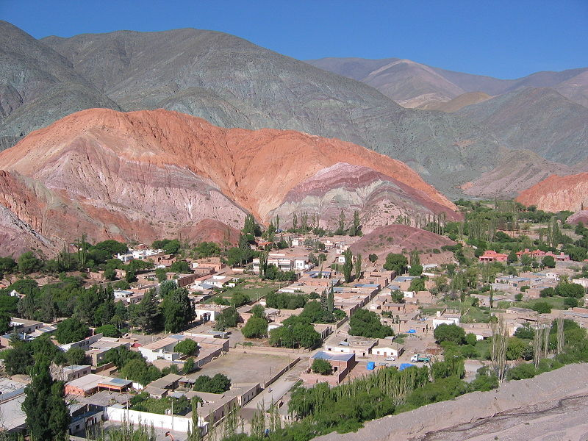
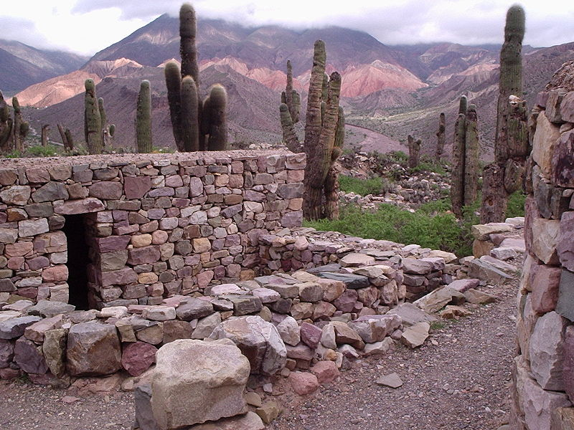

To the northeast, Chaco is a forested area linked to rivers Bermejo, Salado and Pilcomayo. Between the Paraná and Uruguay rivers, the Argentine Mesopotamia (provinces of Entre Ríos, Corrientes and Misiones) is formed by low hills, where pools and marshlands evidence the ancient courses of these great rivers. In some places within the subtropical rain forest, there are fissures which provide such spectacular phenomena as the Iguazú Falls.

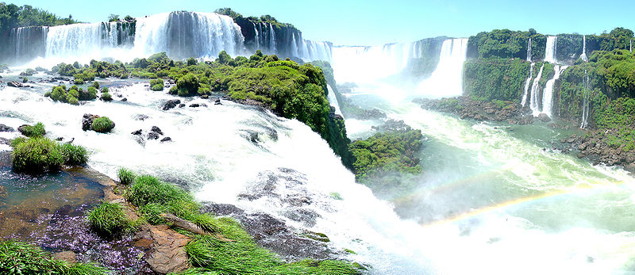
Figure 4 Iguazú Falls
The Pampas, in the central part of Argentina, is the largest and best-known plains area. Agricultural and livestock activities take place in this area, which includes the province of Buenos Aires, the northeast of La Pampa, the south of Córdoba and south of Santa Fe. To the south, the plains give way to small hills in Tandil and de la Ventana, and to the west, to the Córdoba hills. The winds in this zone are strong and constant year-round, making it a good spot for wind-power. This region is also very rich in bio-mass and has potential for bio-fuel energy.

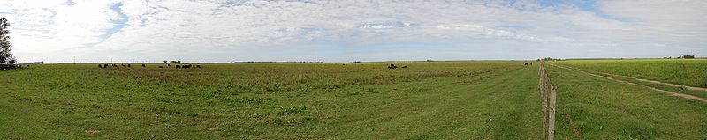 Figure 5 Pampa Humeda (Plains)

In addition to the central plains, the richest region for wind-power is towards the south of the country. From the Andes to the sea are the sterile and stony plateaus of Patagonia, swept by the wind during most of the year. The Atlantic coast, lined with high cliffs, forms massive indentations like the Peninsula Valdés, with its spectacular and unique colonies of sea animals.

Figure 6 Bariloche, Patagonia
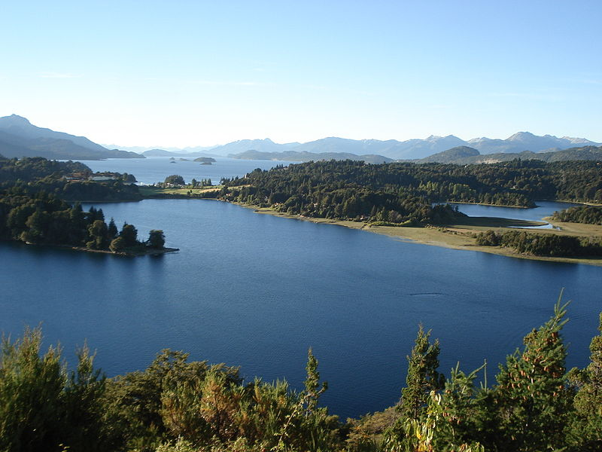
The country’s territory offers a wide variety of climates: subtropical in the North, sub-Antarctic in the southern Patagonia, and mild and humid in the Pampas plains. Media temperature from November to March is 23° C, and 12° C
from June to September.

Argentina’s current population is more than 38 million, almost half of which live in the city and the province of Buenos Aires. This is a population whose increasing demand for energy lies distant from these renewable sources of energy. Thus, bringing renewable energy to these urban populations requires a transmission grid. Population density calculated on a national basis is 14 inhabitants per square kilometer.

Politics

Argentina is a federal, presidential, representative, democratic republic, where the President of Argentina is both head of state and head of government. This is, more often than not, too much power concentrated in just one person. The current President is Cristina Fernandez de Kirshner, the wife of the previous president Nestor Kirshner.

The republic is comprised of 23 provinces and the Federal District: Buenos Aires. The provinces and federal district have their own governments, which makes it hard for consensus on national matters.
During the 1990s, Argentina was regarded as successful in the developing world. It received billons of dollars from foreign investors, inflation rates were low, and the economy was one of fastest growing economies in Latin America. Argentina was a model in international financial lending; it totally complied with the IMF advice.

In 2001, Argentina faced a huge crisis, first economic, then political, and it ended by deeply affecting the entire society. By the end of that year, the government announced that its foreign debt could not be paid back and billions of dollars in government spending would be cut. This translated to government employees receiving a salary reduction of 13% (Pastor and Wise 2001), while at the same time, unemployment skyrocketed to nearly 20% (Stiglitz 2002). In one year, Buenos Aires fell from being the most expensive city in Latin America to the cheapest city (Latin Trade 2003).

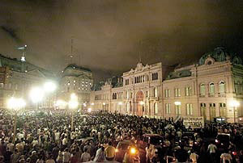
The causes of the Argentinean crisis are still subject to different opinions. Some argue that it was due to the poor policy advice from the IMF (Stiglitz 2002) and others, the IMF among them, blame the irresponsibility and corruption of the Argentine government (Krueger 2002). In fact, the sum of mistaken political decisions, especially regarding the long period in which the fixed exchange rate was held, are among the causes that everyone agrees on.
Figure 7: Caserolazo 2001 at the Pink House (Government)

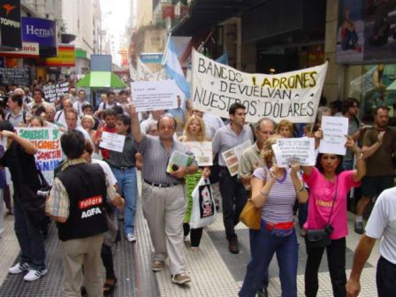
Argentina's economic crisis affected every level of Argentine society and created an air of uncertainty for the future of Argentina. Argentine workers began to withdraw their savings in pesos from banks in exchange for U.S. dollars for fear that rising prices would leave their savings worthless. To curb this cash flight, the Argentine government limited cash withdraws to $250 per month and froze bank assets all together for short periods (Krauss 2001). Additionally, those who took out loans in dollars were faced with repayments that nearly doubled due to the rising interest rates (Lewis 2002). This left people squeezed between rising prices, job uncertainty and limited access to money.
Figure 8 Manifestation in Florida St. Buenos Aires

Stunned by their nation's economic unraveling, Argentines took to the streets in Buenos Aires in protest. The protest was described as a spontaneous demonstration of citizens outraged by the lack of leadership their government exhibited (Evans 2003). The magnitude of the protests and the level of public dissatisfaction with the government's handling of the economy lead to the resignation of the President of Argentina, Fernando de la Rua and the nation's Economic Minister, Domingo Cavallo.

After this huge crisis, Argentina somehow recovered, but there is a lot to be done yet. Moreover since 2008, a public fight between the government and the farmers is taking place and nothing has been done yet. The farmers are just making claim for what is theirs, and the government insists on keeping a significant part of it through tariffs and commerce barriers.
As for the energy sector, this is mainly affected by the lack of flexibility in the commander in chief, and his denial of dialog with some sectors discourages investments. What is more, the current government does not favor foreign external investment, which in other times has helped develop the industrial sector.

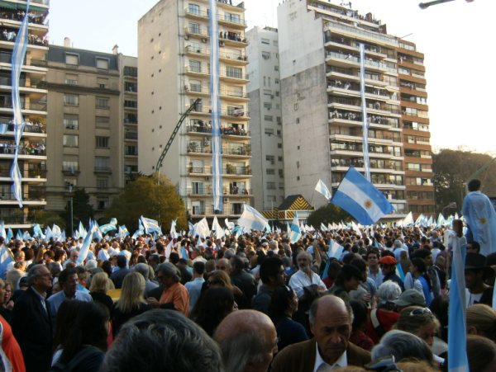
Figure 9: Farmers Act in Buenos Aires 2008 against a Government measure

As a consequence of this, the Head of State is loosing popularity; for instance, the official party lost the congressional elections this year in almost every district. It’s very likely that after 6 years of ruling the country, the Kirshner era is over.

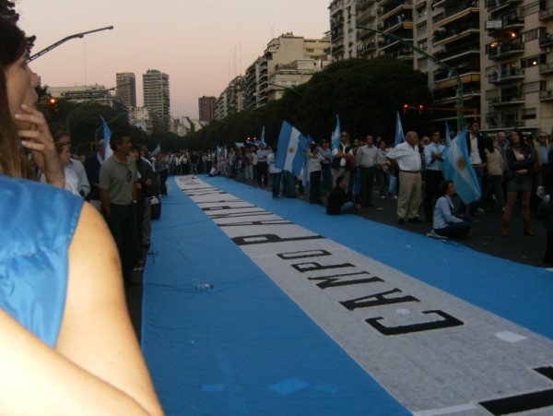
Figure10: Same Act in Buenos Aires, 2008

In addition, in the past few days (Nov, 2009), the social crisis is getting worse due to the economic crisis the world is facing. Nevertheless, as it’s a country quite used to the crisis status, this latest crisis wasn’t as hard as it was elsewhere in the world. However, it has been really bad for the whole country, but also it might be an opportunity for a big change.

Current Sources of Energy

Argentine Electricity Sector: Background

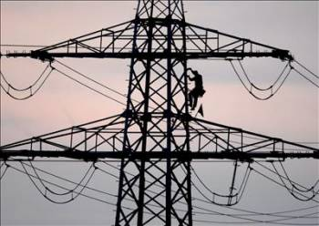
In 1992 electricity was privatized. The objective of the process was to improve the quality of service.

At the end of 2001, as a result of the economic crisis, many electricity generators, transmission companies and distributors deferred making further investments in their networks.
To address this situation, the government established cap prices to the sector that have created a huge structural deficit in the operation of the wholesale electricity market. For many years, no investments were made, and this is part of the current shortages the country is still suffering.
In September 2006, the Secretary of Energy (Secretaría de Energía) issued Resolution No. 1281/06 (“Energy Plus Program”). Through this resolution, companies that consume more energy than in 2005 pay a price equivalent to the cost of generation plus a profit to the generator which must be approved by the aforementioned Ministry. The goal of this resolution is to foster new private, interested parties to invest fresh capital into the energy sector in order to generate new energy sources. This is a great opportunity for renewable energy project development.
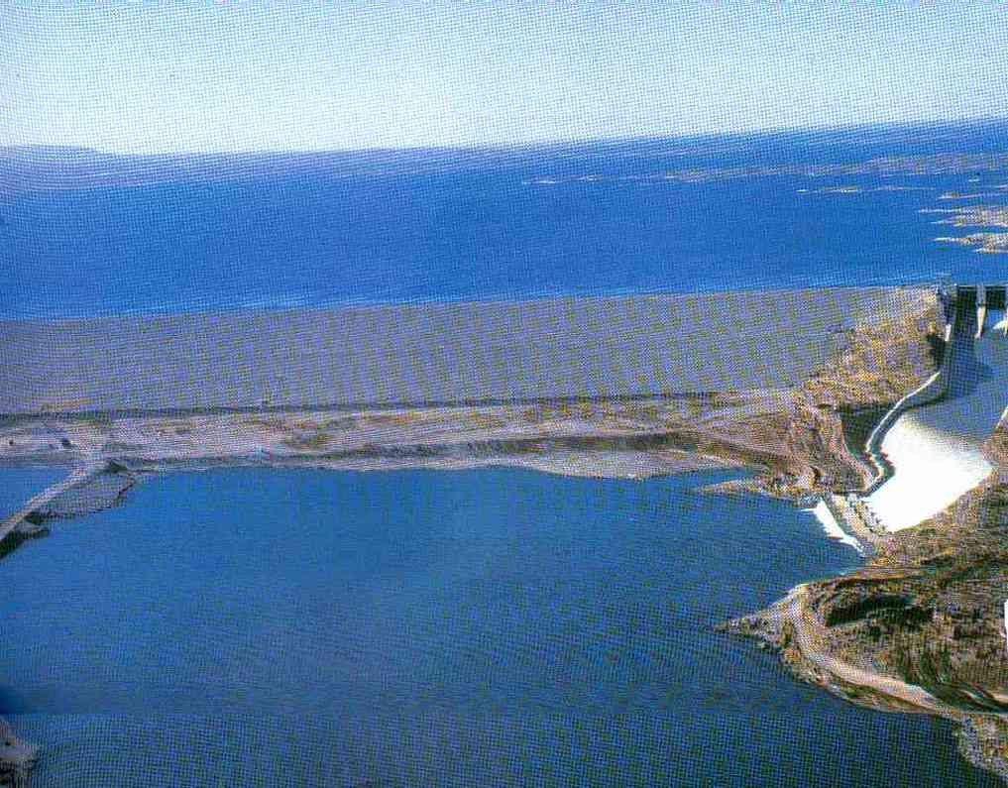
Lastly, in January of 2007, the Executive Branch ratified a tariff increase for industrial and commercial clients of the two largest electrical energy distribution companies of the country, Edenor and Edesur, thereby making official the agreements signed between both companies and the national state in 2005.

Figure 11:3 El Chocon. Hydroelectric Station
Wholesale Electricity Market Participants

The Argentine electricity sector consists of four main groups: generation, transmission, distribution and large consumer companies.

Generators
As of December 31, 2007, Argentina’s installed power capacity was 24,352 MW. 54% was derived from thermal generation (fossil fuel), 42% from hydraulic generation and 4% from nuclear generation. This was provided by 40 private companies using conventional thermal equipment and hydro generation technology, 2 bi-national companies using hydro generation technology and one national state-owned company using nuclear generation technology. This sector used to be subject to the free-market forces. But in the past years, the government has taken part significantly in these transactions, which has discouraged private investments.

Transmitters
Electricity is transmitted from power generation facilities to distributors through high voltage power transmission systems. Transmission services are governed by the Regulatory Framework Law and related regulations promulgated by the Secretariat of Energy. In Argentina, transmission is carried at 500 kV, 220 kV and 132 kV through the national interconnection system. The national interconnection system consists primarily of overhead lines and sub-stations and covers approximately 90% of the country.

Distributors
Each distributor supplies electricity to consumers and operates the related distribution network in a specified geographic area pursuant to a concession. Each concession establishes, among other things, the concession area, the quality of service required, the rates paid by consumers for service and an obligation to satisfy demand. They buy the energy from the generators.

With the crises and the cap prices set up by the government, this industry started to received subsidies… this generated a great level of inefficiency as there was no motivation to do otherwise. As the government ran out of funds, the tariff increase was approved in 2007, which did help, to some extent.

Large Consumers
The wholesale electricity market classifies large users of energy into three categories: Major Large Users (Grandes Usuarios Mayores, or GUMAs),
Minor Large Users (Grandes Usuarios Menores, or GUMEs) and
Particular Large Users (Grandes Usuarios Particulares, or GUPAs).
Each of these categories of users has different requirements with respect to purchases of their energy demand. For example, GUMAs are required to purchase 50% of their demand through supply contracts and the remainder in the spot market, while GUMEs and GUPAs are required to purchase all of their demand through supply contracts

Argentine Demand (Summary of the stated above)

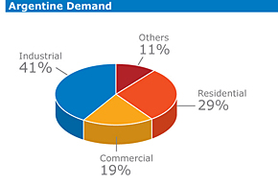
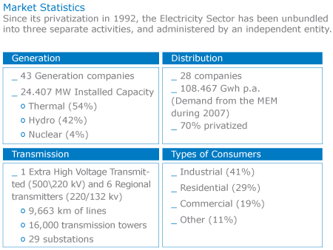
Figure 12: Argentine Demand. Market Statistics
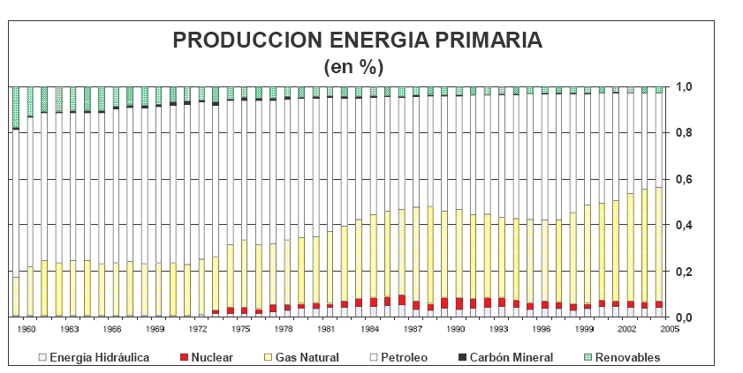
Primary Energy Production in %
Figure 13: Primary Energy Production

The above chart portrays the evolution of the primary sources of energy in Argentina. There is a marked trend to the increase use of natural gas as a primary source. In addition, the renewable sources have declined as the world awareness boosted, which is quite a contradiction and a great challenge if something is to be done.
Another fact is that the Hydroelectric Power is declining, this might be caused by the steadily rise in Natural Gas, but also because of the global warming. This phenomenon is causing severe droughts in the region and they are forecasted to get even worse.

Generation and use of electricity in GWh thousands
 | 1995 | 1996 | 1997 | 1998 | 1999
Net Generation | 71,6 | 72,3 | 76,4 | 80,6 | 77,1
Hydroelectric | 33,4 | 28,4 | 34,8 | 35,8 | 23,7
Nuclear | 7,1 | 6,9 | 7,5 | 7,1 | 6,7
Wind and Solar | 0,1 | 0,1 | 0,1 | 0,2 | 0,2
Conventional Thermal Power | 31,0 | 36,8 | 34,0 | 37,5 | 46,5
Net Use | 68,7 | 70,6 | 76,1 | 82,2 | 77,1
Imports | 2,4 | 3,7 | 5,3 | 7,9 | 6,5

Argentina has 43 electricity generating stations. Their installed capacity is over 100 MW. Moreover, there are many small generators located in remote places.
The 77,100 GWh were generated in the following way:
Conventional Thermal Power Stations (Most of them use natural gas) | 60,3%
Hydroelectric Stations | 30,7%
Nuclear Stations | 8,7%
Wind and Sun Power | 0,3%

Composition of Installed Capacity:

 | 1999
Conventional Thermal Power Stations | 12.880 MW
Hydroelectric Stations | 9.350 MW
Nuclear Stations | 1.018 MW
Small Stations | 1.002 MW
Total | 23.250 MW
Total Generation | 77.100 GWh
Net Use | 77.100 GWh

Thermal Power Stations
- Combined Cycle Power Plants with gas turbines and installed capacity

Costanera | 1.425 MW
Genelba | 440 MW
Luján de Cuyo | 431 MW
El Bracho | 430 MW
Puerto Madryn | 153 MW
General Lavalle | 127 MW

- Simple Cycle Plants with gas turbines:

Luis Piedra Buena | 695 MW
Agua de Cajón | 517 MW
Sorrento | 388 MW
Loma de la Lata | 369 MW
General Savio | 180 MW
Ave Fénix | 166 MW
Puerto Madryn | 153 MW
Buenos Aires | 150 MW
Hydra | 136 MW
9 de Julio | 130 MW
Dock Sur Segba | 130 MW
Sur Oeste | 124 MW
Refinería La Plata | 123 MW
General Roca | 123 MW

- Conventional Steam Plants:

Central Puerto | 1.009 MW
Pedro de Mendoza | 383 MW
San Nicolás | 350 MW
Guemes Powerco | 313 MW
Pilar | 216 MW
Dock Sur | 211 MW
Necochea | 122 MW

d) Hydroelectric Plants, installed capacity:

Yacyretá | 2.700 MW
Salto Grande | 1.890 MW
Piedra del Aguila | 1.424 MW
El Chocón | 1.227 MW
Alicurá | 1.028 MW
Río Grande (por bombeo) | 750 MW
Cerros Colorados | 450 MW
Futaleufú | 448 MW
Los Reyunos | 224 MW
Agua del Toro | 150 MW
Piedras Moras | 145 MW
Uruguai | 120 MW
Arroyito | 120 MW
Cabra Corral | 102 MW

e) Nuclear Plants, installed capacity:
Atucha I | 360 MW
Embalse | 658 MW
Renewable Energy Potential of Argentina

As we had previously mentioned, the diversity in weather conditions and terrain make each region very rich in one or more potential renewable energy sources. The following maps present the renewable potential per region.
Potential per region

BIO-MASS
SOLAR
TRASH
BIO-GAS
BIO-FUEL
BIO-MASS
WIND POWER
BIO-FUEL
BIO-MASS
HYDRO
WIND POWER
HYDRO
WIND POWER
GEOTHERMAL
BIO-MASS
SOLAR
WIND POWER
BIO-MASS
SOLAR

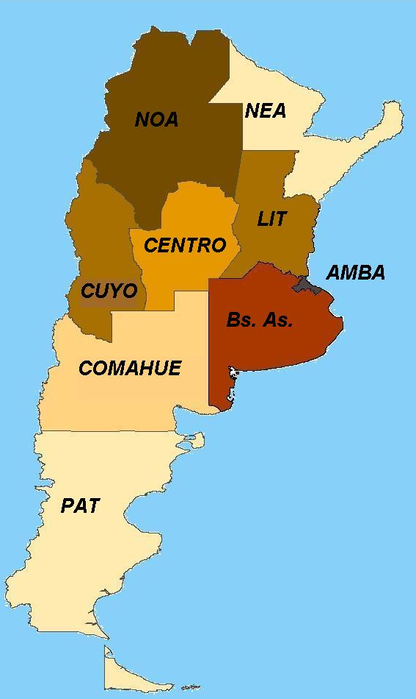
Figure 14 Potential per Region
Hydro

The hydropower potential is located mainly in the Andes Mountain because of the great currents generated by the rivers’ thaws in spring and summer. Another great location are the Iguazú Falls (Fig. 5).

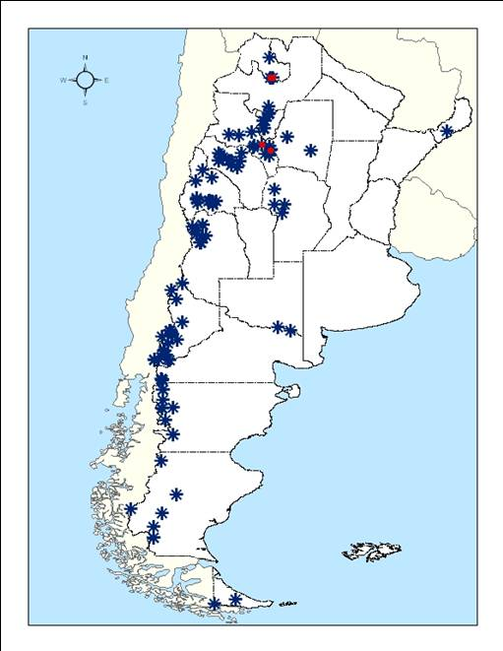
Figure 15: Hydro Potential

Bio-energy
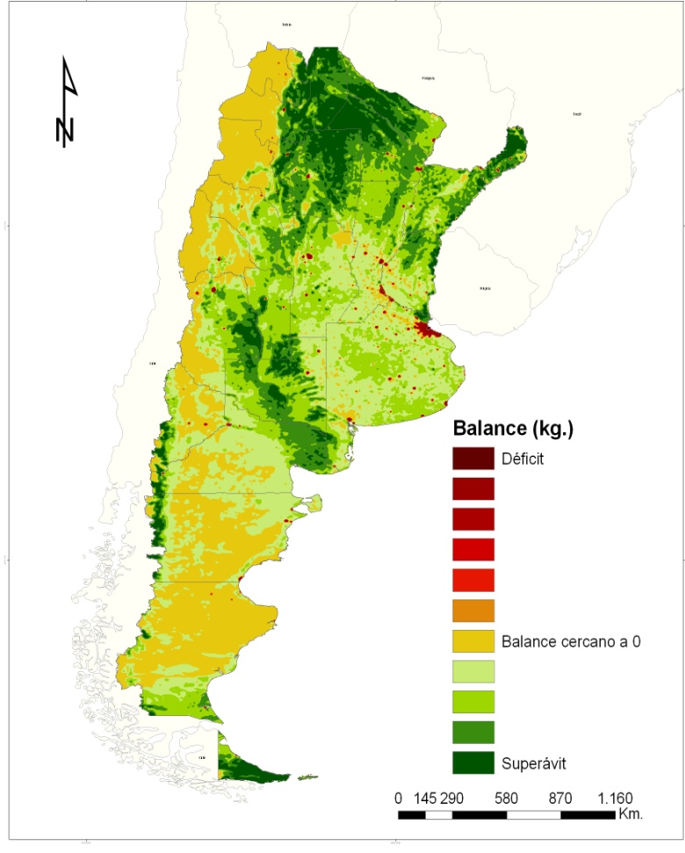
Figure 16 Bio-energy Potential

Wind Power

The potential for wind power is large in the country. The greatest potential is concentrated to the south of the country where the winds are constant year round.

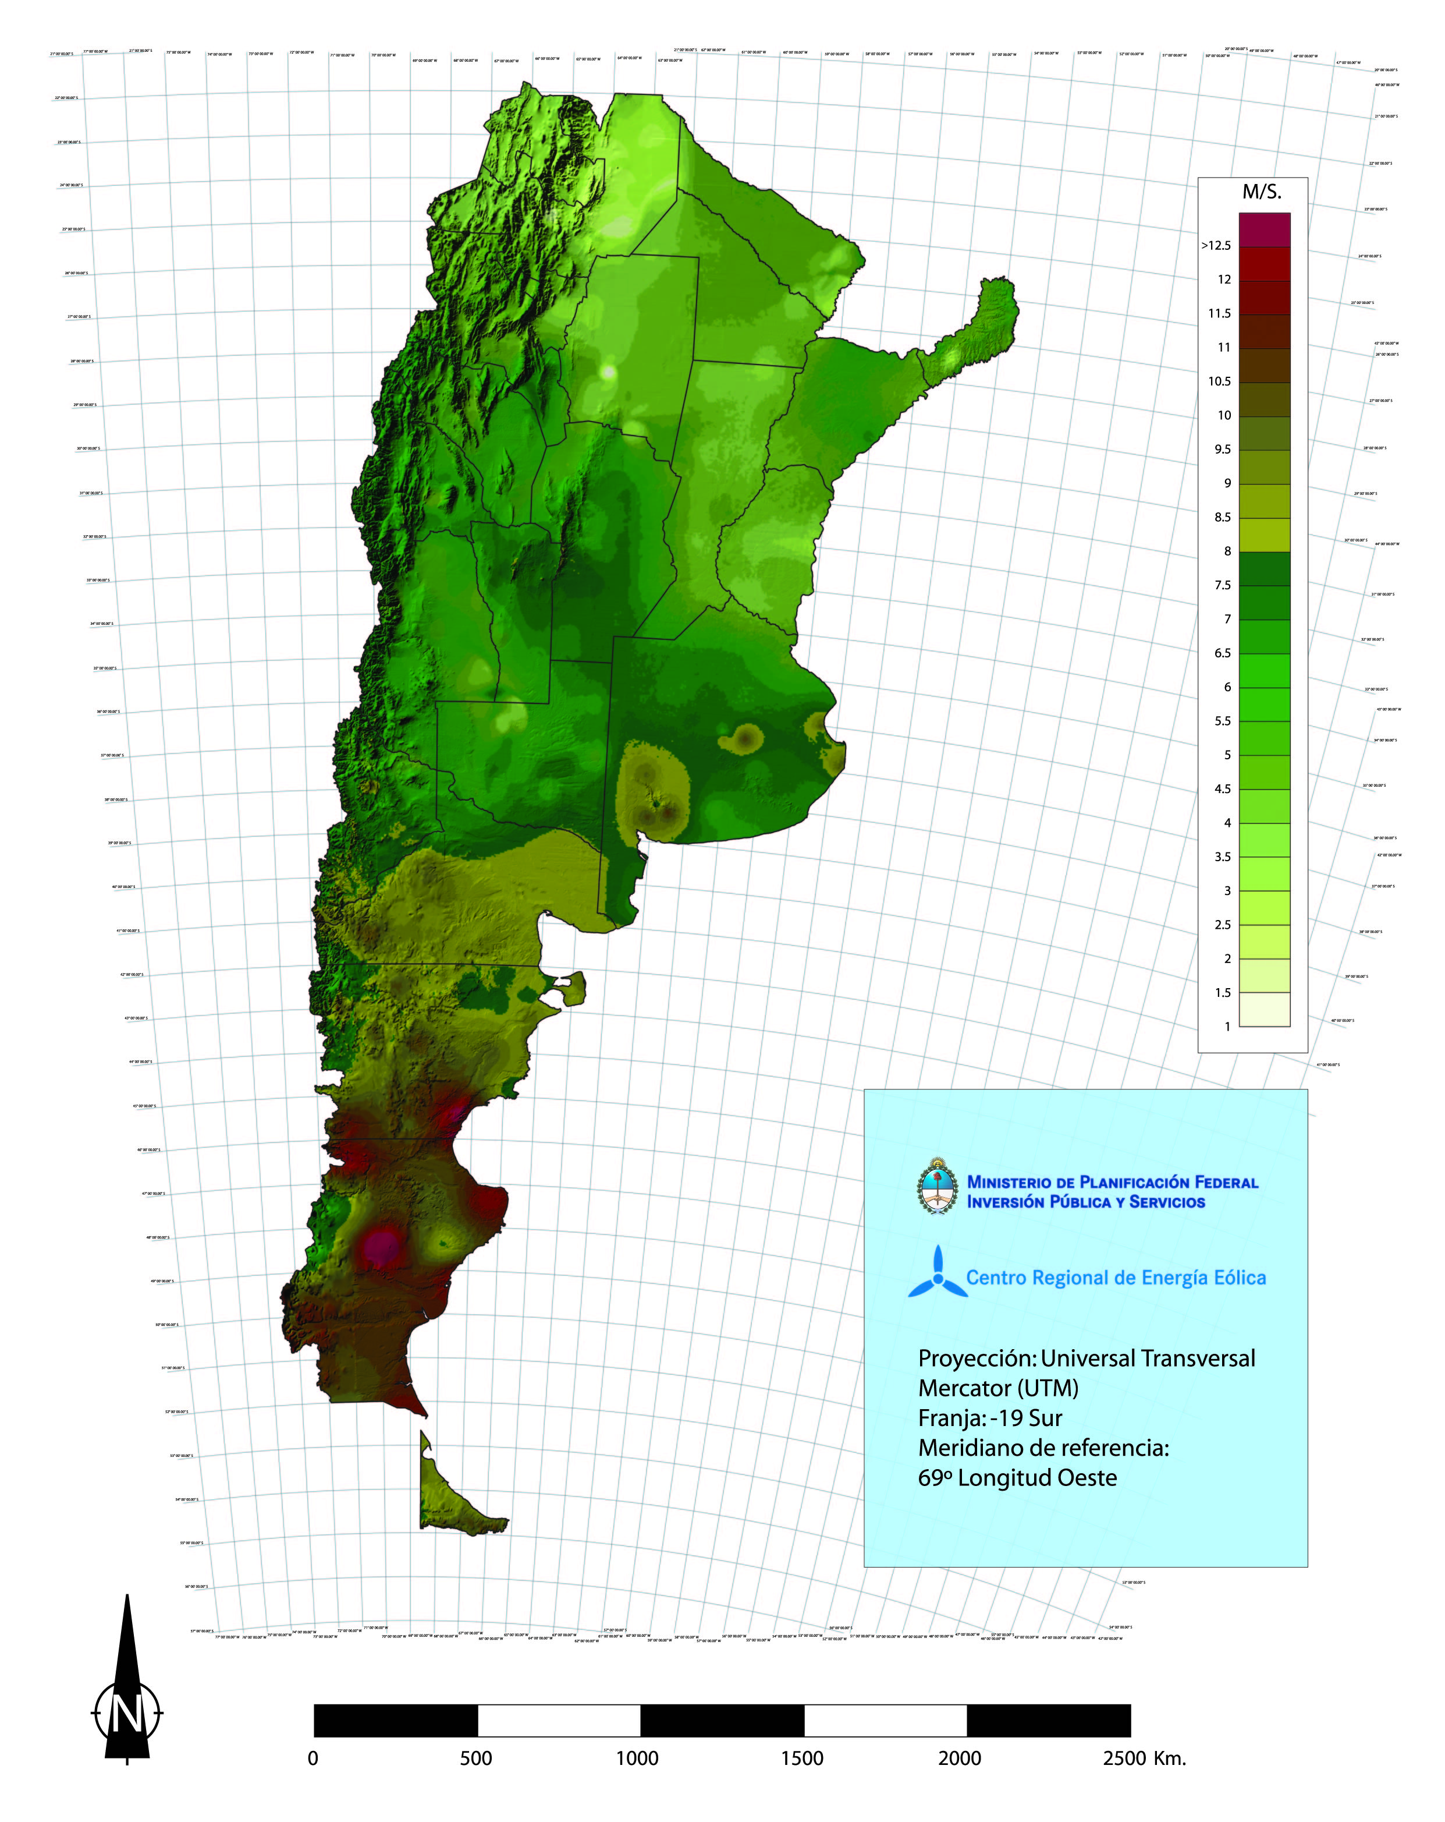
Figure 17 Wind Power Potential

Legislation

Law # 26.190, this law was sanctioned in the year 2006. Its main implicit aims are to:
- Diversify the main energy resources
- Reduce the cost of fossil fuels
- Create employment
- Promote investments

The explicit aims there are to:
- Establish the generation of energy out of renewable resources as a matter of national interest.
- Set as an objective that in 10 years from now, 8% of the use of energy is supplied out of renewable energy resources.
- Encourages the use of energy coming from wind, sun, geothermal, tidal, hydro, bio-mass, gas from rubbish dumps and depuration plants and bio-gas.
- Establishes differentiated per source incentives for 15 years.
- Creates a fiduciary fund for renewable energies.

This law is a positive encouragement for the investments in the renewables sources of energy. Nevertheless, the rules aren’t clear yet, so no major move has been made by any private company.

A few months ago, a program was made public:
- GENREN program
By this program renewable sources of energy were put into tender
Geothermal
Solar
Power to tender
Figure 18 Power to tender in the GENREN Program
Small
Hydropower
Bio-Gas
Bio-Mass

Urban Waste

Wind Power
Bio-fuels

- Energía Argentina Sociedad Anónima (ENARSA) would invite tenders for the acquisition of energy coming from renewable resources.
- Offers will be accepted up to 50 Mw.
- ENARSA will sell the energy to the Electric Market via 15 years contracts.

In this way they promote investment in the industry, it creates thousands of jobs and reduces the emission of greenhouse gases.

Lastly, as part of the commitment the government is undertaking with renewables, in the past year a program was implemented: Programa Nacional de Uso Racional y Eficiente de Energía “PRONUREE”

The results were the following:
- 7 million of low-consumption bulbs distributed
- 4 millon of homes reached
- 18 millon of bulbs yet to be distributed
- Efficiency applied to the Public Lighting System in 140 city-councils

Even though, there is still a lot to be done in legislation matters, it is verly encouraging to see that some action is taking place.
Ongoing projects

This map is shown to portray some of the projects already functioning. Nevertheless, when compared to the potential maps, they represent just a small percentage. There is a lot of potential yet to be exploited.

Figure 19 Ongoing Renewable Energy Projects
Hydroelectric Stations in different project stages
 |  |  | Stations | Installed Capacity (MW) | Annual Average Energy (GWh/year)
El chihuido I | 850 | 2.395
El Chiuido II | 420 | 1.050
Alta Cuenca Collón Curá | 706 | 2.910
Collón Curá | 376 | 1.492
Segunda Angostura | 120 | 450
Pichi Picún Leufú | 251 | 1.020
Michihuano | 617 | 2.923
Los Monos | 77 | 227
La Leona | 240 | 983
Carrenleufú | 240 | 1.158
Río Santa Cruz | 2.000 | 9.000
 |  |  |  | 5.897 | 23.608
Garabí | 900 (.) | 3.125
Roncador | 1.980 (.) | 4.650
San Pedro | 370 (.) | 1.840
Corpus | 4.600 (..) | 20.100
Patí | 2.857 | 15.530
Chapetón | 3.000 | 18.625
 |  |  |  | 13.707 | 63.870
Los Blancos I | 324 | 802
Los Blancos II | 150 | 390
Cordón del Plata | 1.382 | 3.275
 |  |  |  | 1.856 | 5.007
TOTAL |  |  |  | 21.460 | 92.485
(.) bi-nacional stations: assigned power to Argentina (50%).
(..)bi-nacional station: Argentina will absorb the 100% of the power
400 MW can be added. Coming from the Yacireta level raising to 83 m. The costs will be paid in four years of export.
Argentina and Its Neighbors
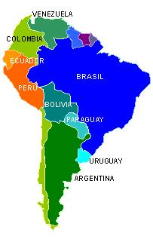
Researches and studies have been made to prove the possibility of integrating the electricity market in the Mercosur countries. The efforts have been made especially by Chile, who is very interested on this as it imports most of its energy.
Hugh Rudnick, professor at The Pontificia Universidad Católica de Chile, has been conducting some researches and doing some presentations on the topic. One of his core ideas is that all the countries have the same conditions in the sector:
- General liberalization and privatization
- The trend to split business into accountable and legal
- Regulations in the natural monopolies. Private initiative is given more importance than the public one.
- Capitalize on costs so as to offer a lower price
- Interconnections tend to more and more free access
- The electricity is a commodity and a special good
Transnational markets are the trend, so it would be very important to promote integration among these countries. In addition, they have different uses and production, so there might be an excess in one of them that another can take advantage of.
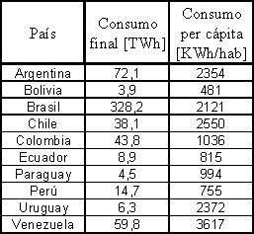
In 1994, these were the uses of energy per country:
The following is a list of the existing networks:
· Argentina - Chile
Termoandes (not linked to the MEM 300 MW Line )
· Paraguay - Argentina
Yacyreta ( 1700 MW Generation Station)
Clorinda ( 80 MW Line )
· Paraguay – Brazil
Itaipu ( 12.600 MW Generation Station)
· Uruguay - Brazil
Livramento ( 70 MW Line )
· Argentina - Uruguay
Salto Grande ( 1.890 MW Generation Station)
· Argentina - Brazil
Paso de los Libres - Uruguaiana ( 50 MW Line)
Rincón - Garabi - Ita I
Rincón - Garabi - Ita II( 1000 MW line under construction)
Total Network Power (working, under construction and projected) = 5.023 [MW]
Total Installed Power (working) = 151.707 [MW]
The network power is still a small percentage if compared to the total installed power. This presents another challenge for the region. Although some integration was attained, there is so much to be done yet.
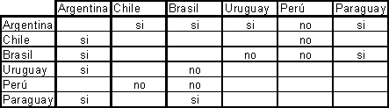
Figure 20 South American Interconnection Agreements. (Read SI for YES).

The chart shown above portrays the need of network development. This could be a great opportunity for renewables.
The interconnection Agreements are beneficial for the following reasons:
- The Energy Exchange can satisfy demand in places with higher population growth.
- New technologies can be implemented.
- There can be access to larger economies in a broaden market.
- The regional resources can be used efficiently.
- The quality of the service for end-users can be improved
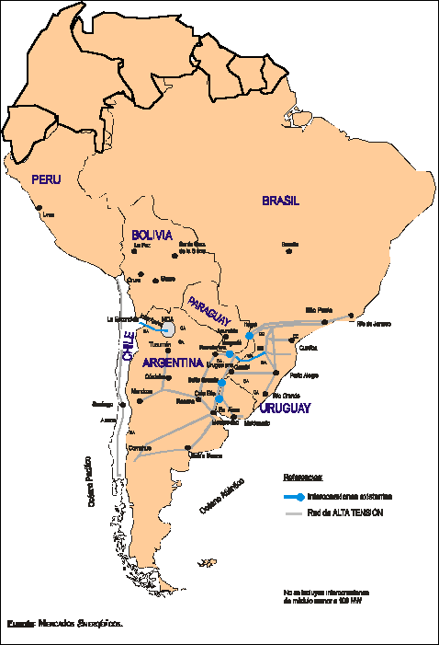
Figure 21: Energy transportation in South America.
Fuente: Mercados Energéticos

Conclusions
After having conducted the research on Argentina, the findings were always around the same idea: there is a lot yet to be done.
Argentina has great potential for renewables, mainly due to its varied geography and climate throughout the country. An example would be that wind power farms could be installed in more than half of Argentina’s Natural Territory.
Fortunately, the Government is starting to engage with the renewable cause. Nevertheless, there are so many other matters in its agenda that the energy is not receiving proper treatment.
For instance, in 2008 Argentina spent $1,800 millions USD buying fuel and thermal energy from abroad. If 15% of that cost had been addressed to the purchase of wind power, 700MW of wind power could have been installed, getting investments for over $1,500 millions USD.
The previous, is a clear example of the Government attitude towards the renewables.
As the international crisis is starting to ease off and as people around the world are getting more and more concerned about environmental matters, Argentina, and many other underdeveloped countries, are potential destinations for investments for the production on green energy.
Yet, the country being addressed has another challenge to face: to strengthen the links with its neighbors.
Biography:
- http://www.deyseg.com.ar/notas/actualidad/aanota35-politica.htm
- Programa “GENREN”, Ministerio de Planificacion Federal Inversion Publicas y Servicios, May 2009.
- Bretton Woods Project (2004). IMF's "role put into question": Argentina crisis evaluation. 10th August 2004. Retrieved on 8/17/2004 at <http://brettonwoodsproject.org/article.shtml?cmd[126]=x-126-65659>
- Evans, Leslie (2003). "The Crisis in Argentina" UCLA Latin American Center, April 2003 Retrieved on 8/17/04 at http://www.international.ucla.edu/article.asp?parentid=3566
- Feldstein, Martin (2002). "Argentina's Fall". Foreign Affairs; Mar/ Apr 2002 vol. 81, i 2, p 8. Retrieved on 8/17/04 at http://web4.infotrac.galegroup.com/itw/infomark/322/647/53760740w4/purl=rc1_EAIM_0_A82782317&dyn=8!xrn_1_0_A82782317?sw_aep=
ucsantacruz
- Hutchinson, Martin (2002). "Where next in Argentina?" United Press International; Oct. 21, 2002. Retrieved on 8/17/2004 at http://web4.infotrac.galegroup.com/itw/infomark/380/194/53762304w4/purl=rc1_EAIM_0_A93218030&dyn=3!xrn_1_0_A93218030?sw_aep=
ucsantacruz
- International Monetary Fund (2004). Report on the Evaluation of the Role of the IMF
in Argentina, 1991Ð2001. Retrieved on 8/17/2004 at http://www.imf.org/External/NP/ieo/2004/arg/eng/index.htm
- Jeter, Jon (2003). "Scrap by Scrap, Argentines Scratch out a meager living. Laid-off workers survive as trash pickers". Washington Post; June 7, 2003; Page A01.
- Krauss, Clifford (2001). "Argentina Limits Withdrawals as Banks Near Collapse". New York Times (1857 Ð current files); December 3, 2001; ProQuest Historical Newspapers The New York Times; page A3.
- Kiguel, Miguel (2002). "Structural Reform in Argentina: success or failure?" Comparative Economic Studies. Summer-Fall 2002, p83(20).
- Krueger, Anne (2002). Crisis Prevention and Resolution: Lessons from Argentina. International Monetary Fund. Retrieved on 8/17/2004 from http://www.imf.org/external/np/speeches/2002/071702.htm
- Latin Trade (2003). "Living on Less" October 2003 v11 i10 p71(1) Retrieved on 3/31/04 at http://web4.infotrac.galegroup.com/itw/infomark/322/647/53760740w4/purl=rc1_EAIM_0_A109944696&dyn=3!xrn_7_0_A109944696?sw_aep=
ucsantacruz
- Lewis, Tom "Argentina's Revolt" International Socialist Review; Jan-Feb. 2002. Retrieved 3/31/04 at:
http://isreview.org/issues/21/argentinas_revolt.shtml
- Maniam, Balasundram, Hadley Leavell, Vrishali Patel (2004). "Financial Crisis in Emerging Markets: Case of Argentina." Journal of American Academy of Business, Cambridge. March 2004 v4; i1/2; p434.
- Pastor, Manuel; Carol Wise (2001). "From Poster Child to Basket Case." Foreign Affairs; Nov-Dec 2001; v80, i6; p60
- Rohter, Larry (2003). "Once Secure, Argentines now lack food and hope" The New York Times March 2, 2003; Section 1; Column 1; Foreign Desk; Pg. 8. Retrieved on 8/17/2004 at http://web.lexis-nexis.com/universe/document?_m=31ac83a87111dea6c71717798daa14ad&_docnum=1&wchp=
dGLbVtz-zSkVb&_md5=449b60d2240c466261e9f01c0cb6314f
- Sorensen, Morten (2001). "Argentina's Crises" Danmarks National Bank 21/21/2001. Retrieved on 8/17/2004 at http://www.nationalbanken.dk/C1256BE9004F6416/side/B464DADA01662394C1256E7B0041037B/$file/2001_MON4_arg81.pdf
- Stiglitz, Joseph "Argentina, Shortchanged. Why a nation that followed the rules fell to pieces" www.globalpolicy.org/socecon/bwi-wto/imf/2002/0512shortchange.htm
- http://www2.ing.puc.cl
- http://www.deyseg.com.ar
- www.argentinarenovables.org
- www.iredenor.com
- www.turismo.gov.ar
- www.wikipedia.org

http://en.wikipedia.org/wiki/Argentina
http://www.summitpost.org/view_object.php?object_id=146685
http://en.wikipedia.org/wiki/File:Pucar%C3%A1_de_Tilcara_01.JPG
http://en.wikipedia.org/wiki/File:Cerro_de_los_siete_colores.jpg
http://en.wikipedia.org/wiki/File:Iguazu_D%C3%A9cembre_2007_-_Panorama_5.jpg
http://en.wikipedia.org/wiki/File:Campo_Departamento_Conhelo.jpg
www.turismo.gov.ar/eng/menu.htm
http://en.wikipedia.org/wiki/File:Llao_LLao.jpg
http://img213.imageshack.us/img213/244/foto14kg3.jpg
http://fourierlangues.fr/espagnol/public/Images/N-ALCAZAR/suramerica/.Cacerolazo_Argentina_2001-2002_m.jpg
http://www.telpin.com.ar/interneteducativa/Proyectos/2002/PatagoniaArgentina/images/chocon.jpg
http://www.iredenor.com/argentine_electricity_sector
http://www.iredenor.com/argentine_electricity_sector/market_statistics/
http://www.iredenor.com/argentine_electricity_sector/market_statistics/
Argentina Energy Secretariat
Ihttp://www.deyseg.com.ar/notas/actualidad/aanota35-politica.htm
Regional Wind Power Center, Ministery of Federal Planification, Public Investment and Services.
Argentine Energy Corporation
National Program for The Rational and Efficient Use of Energy
http://www2.ing.puc.cl/power/alumno02/sicsadi/Estudio_Bibliografico.html
http://www2.ing.puc.cl/power/alumno02/sicsadi/Estudio_Bibliografico.html

